**Islamabad Boys Scout Association**

**Volunteer Service Placement Report**

Start Date

**3rd September 2022**

End Date

**14th September 2022**

*Near Helipad, Sumbal Park, Garden Avenue, Adjacent to Pakistan Boy Scouts Association NHQ Islamabad*

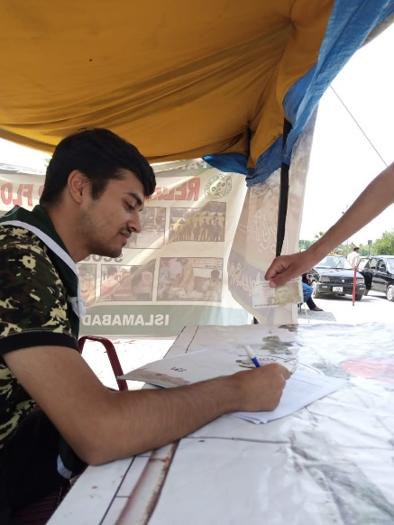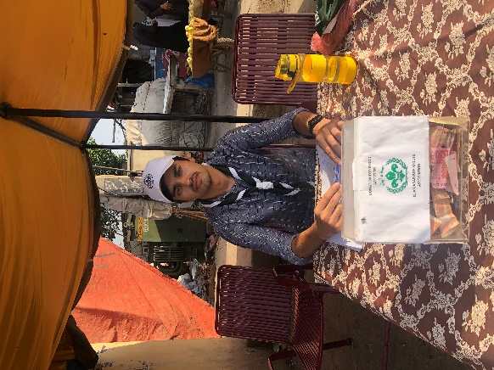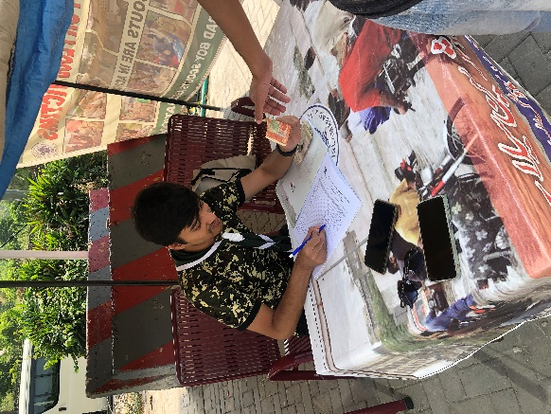

**Muhammad Harris** – BCS203193



Capital University of Science and Technology, Islamabad

# Contents

***1 Contents 1***

***2 Introduction of Individual 2***

***3 Organization Profile 2***

*3.1 About IBSA 2*

*3.2 Mission of IBSA 2*

*3.3 What IBSA Does? 2*

*3.4 IBSA & Quaid-e-Azam Muhammad Ali Jinnah 3*

***4 Overview 3***

***5 Scope of VIS Activities 4***

***6 Date /Day wise Activities 5***

***7 Summing Up 6***

***8 Lessons Learnt 6***

***9 Recommendations and Suggestions 6***

***10 Views About Organization 6***

***11 Working Pictures 7***

# Introduction of Individual

|  |  |
| --- | --- |
| **Name of the Student** | Muhammad Harris |
| **Registration Number** | BCS203193 |
| **Course** | Bachelors in Computer Science (*BSCS*) |
| **Batch** | Fall 2020 |
| **Contact Number** | 0333-8102886 |
| **Email** | harris20014@gmail.com |
| **Mission in life** | To acquire and have a strong grip on all skills necessary to be a successful web developer or data analyst. Work hard and make my parents proud. |

# Organization Profile

## About IBSA

**Islamabad Boy Scouts Association** is a well-recognized governmental organization and it is affiliated with PBSA and is assigned for training and recruiting of scouts.

Scouting was founded in Pakistan as a part of the British Indian branch of The Scout Association. The PBSA was officially founded in 1947, immediately after independence from the British and became a member of the World Organization of the Scout Movement in April 1948. *The First Chief Scout of Pakistan was Quaid-e-Azam Muhammed Ali Jinnah*. Islamabad Boys Scouts Association was established in 1980 and was approved by National Council Meeting on 22 February, 1983.

## Mission of IBSA

*The Mission of Scouting is to contribute to the education of young people, through a value system based on the Scout Promise and Law, to help build a better world where people are self-fulfilled as individuals and play a constructive role in society.*

## What IBSA Does?

Islamabad Boy Scouts Association is affiliated with PBSA and is assigned to recruit and train scouts in Islamabad and its adjacent areas. The training courses and sessions are offered and executed as per scheduled designed pattern which includes all activates and sessions such as Scouts registration, basic understanding of Scouting, Scout lessons, camping hiking and others which ends up with its closing ceremony.

Scouting can play a very vital role in forming the character of our youth, promoting their Spiritual, Intellectual, Social and Emotional development and making them well disciplined, useful and good citizens.

Scouts have gained the respect of the citizens for their untiring work during floods, earthquake and other human and natural disasters. They have collected and distributed food and clothing. They have evacuated trapped people to safety, and run first aid stations in refugee camps. They have been active in helping rebuild destroyed villages. Scout program emphasis is on community service and conservation.

## IBSA & Quaid-e-Azam Muhammad Ali Jinnah

Quaid-e-Azam Muhammad Ali Jinnah was the first Chief Scout of Pakistan. On Scouting, Pakistan's founder Muhammad Ali Jinnah said

“Scouting can play a very vital role in forming the character of our youth, promoting their physical, mental and spiritual development and making them well disciplined, useful and good citizens. We are living in a far from perfect world. Despite the progress of civilization, the law of jungle, unfortunately, still prevails. Might is considered right and the strong do not refrain from exploiting the weak. Self-advancement, greed and lust for power sway the conduct of individuals, as that of nations.”

# Overview

On August 14th 2022, Pakistan declared a state of emergency because of the flooding. The floods were caused by heavier than usual rainfall and melting of glaciers that followed a severe heat wave, all of which are linked to climate change. It was the worst flood in history of Pakistan. 1/3rd of the country was underwater affecting 33 million people.

It was topmost priority of every citizen of Pakistan to contribute and save people affected by flood from hunger and flood itself. **Hence, I volunteered to collect donations for flood victims through VIS program and was assigned to Islamabad Boys Scout Association as a volunteer.**

Before the volunteering began, I had no idea what I was getting into. However, deep inside, I knew it wasn’t a waste of time as every second of my work would be an effort to save a flood victim’s life.

On my very first day at Islamabad Boys Scout Association, I was guided on how we will be collecting donations for flood victims. The staff at IBSA was very cooperative and helpful. I was given meaningful tasks to perform and my efforts were recognized.

Overall, I was satisfied with my well spent time at Islamabad Boys Scout Association. This experience completely change the way I used to think about VIS.

# Scope of VIS Activities

Volunteer Service is an act in recognition of a need, with an attitude of social responsibility and without concern for monetary benefits going beyond ones basic obligations. It is our religious obligation to volunteer to help the ones in need.

VIS Program is an initiative to engage our youth in volunteer community service so as to give them a view of the flipside of the picture, to make them aware about the hunger, deprivation, ailments and social problems that people, living around us, face each day.

The following are the benefits of the VIS program,

* Allows the student to understand feelings and share pain of community.
* Students learn ethics of caring.
* Students become pioneers and trend setters for volunteering.
* Student’s efforts are recognized and accredited.
* Helps an organization to be socially accountable to itself, its stakeholders and community.
* Students become more responsible citizens.
* Helps in character building of students.
* Contributes towards partnership with social sector.
* Results in a better society with far less problems.
* Provides more helping hands for the needy.
* Provides support for the community.

In my opinion, VIS has a very broad scope of activities which may differ from person to person. These activities allow a person to become more responsible citizen in every aspect making them a more mature person. For our youth, these activities could be a source of motivation towards a bigger change in our society.

Only through my voluntary work at Islamabad Boys Scout Association, I came to realize the importance of this program. I was made aware of the pain and suffering of the flood victims and the change I can bring to their lives by helping them financially. VIS program made me a more mature person and encouraged me to help people in need more often.

# Date /Day wise Activities

|  |  |  |
| --- | --- | --- |
| Date | Date | Activity |
| 3rd September 2022 | Saturday | On my first day, I was given a brief introduction to what scouting was. I was also educated about flood situation in Pakistan and how we will be contributing towards flood relief efforts. |
| 4th September 2022 | Sunday | On my second day, we took permission from the authorities to establish a relief camp at Centaurus Mall, Islamabad. |
| 5th September 2022 | Monday | After we got permission from the authorities, on the next day, we got all the equipment required to setup a camp. |
| 6th September 2022 | Tuesday | On this day, camp was setup at Centaurus Mall, Islamabad. I learned for the first time how to setup a tent. |
| 7th September 2022 | Wednesday | On this day, we started collecting donations for flood victims at our camp at Centaurus Mall, Islamabad. |
| 8th September 2022 | Thursday | On this day, We continued our collection of donations for flood victims at our camp at Centaurus Mall, Islamabad. |
| 9th September 2022 | Friday | Overnight rain had destroyed our camp. Hence, we had to setup our camp again. |
| 10th September 2022 | Saturday | On this day, We continued our collection of donations for flood victims at our camp at Centaurus Mall, Islamabad. |
| 11th September 2022 | Sunday | **Day off** |
| 12th September 2022 | Monday | **Day off** |
| 13th September 2022 | Tuesday | On this day, we collected all the donations received and transferred everything to Islamabad Boys Scout Association Office, Islamabad. In the evening, packed our camp from Centaurus Mall, Islamabad as we were about to shift the camp and collect donations from a different location. |
| 14th September 2022 | Wednesday | We did a lot this day. In the morning, we got permission from the authorities to setup a camp at Sabzi Mandi, I-11, Islamabad. After we got permission, we were quick to transfer all camp equipment from Islamabad Boys Scout Association Office, Islamabad to our new site. We setup the camp and started collecting donations. At last I bid farewell to the organization as it was my last day of volunteering. |

# Summing Up

Before the volunteering began, I had no idea what I was getting into. However, deep inside, I knew it wasn’t a waste of time as every second of my work would be an effort to save a flood victim’s life. Each day I spent with Islamabad Boys Scout Association, I had something new to learn. Staff at Islamabad Boys Scout Association was very cooperative. After closely working with Islamabad Boys Scout Association I came to realize the importance of this organization in our community. Scouts at Islamabad Boys Scout Association have gained the respect of citizens for their untiring work during flood. They have collected and distributed food and clothes. They have evacuated trapped people to safety, and run first aid stations in refugee camps. They have been active in rebuilding destroyed villages.

Overall, I was satisfied with my well spent time at Islamabad Boys Scout Association. This experience completely change the way I used to think about VIS. Only through my voluntary work at Islamabad Boys Scout Association, I came to realize the importance of this program. I was made aware of the pain and suffering of the flood victims and the change I can bring to their lives by helping them financially. VIS program made me a more mature person and encouraged me to help people in need more often.

# Lessons Learnt

Through my activities at Islamabad Boys Scout Association as a volunteer, I learned many things. I learned how to create a camp on my own and many other things related to scouting. But most importantly I learned that many small contributions can lead to a single greater change in our society. This was surely a paradigm shift for me that we could make a groundbreaking change if we stand united against all odds.

# Recommendations and Suggestions

I would suggest the organization that staff at Islamabad Boys Scout Association should be supervised more strictly and a sense of responsibility should be created among younger staff members.

As for VIS, volunteers should be given a complete timetable of their tenure at the organization that should also comprise activities that are needed to be performed.

# Views About Organization

Islamabad Boys Scout Association is a hardworking organization that has contributed greatly towards flood relief. Staff is very cooperative and friendly. Scouts at Islamabad Boys Scout Association have gained the respect of citizens for their untiring work during flood. They have collected and distributed food and clothes. They have evacuated trapped people to safety, and run first aid stations in refugee camps. They have been active in rebuilding destroyed villages.

# Working Pictures

